|  |
| --- |
| 4 essential skills every .NET developer must possess | TechGig |
| Web Development  Muhammad Arbab Anjum |
| |  |  |  | | --- | --- | --- | | Muhammad Arbab Anjum | 5/15/20 | CSS Animations | |

**Transform:**

**Move:**

transform: translateX(300px);

transform: translateY(300px);

transform: translateZ(300px);

**Rotate:**

transform: rotateX(30deg);

transform: rotateY(30deg);

transform: rotateZ(30deg);

**Stretch:**

transform: scaleX(2);

transform: scaleY(2);

transform: scaleZ(2);

**Transitions:**

Moving element form one place to another.

transition: 1s;

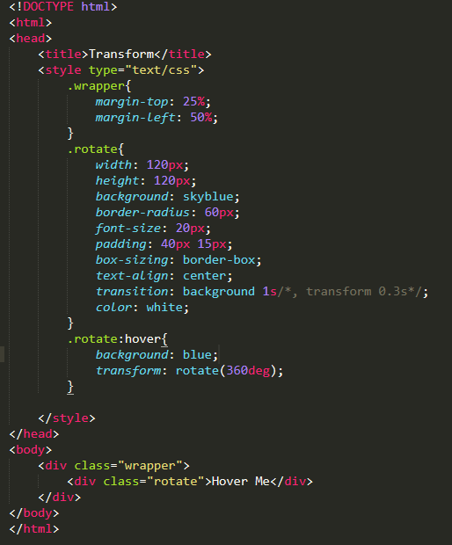

Key Frames:

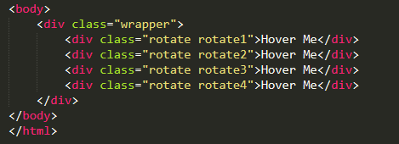

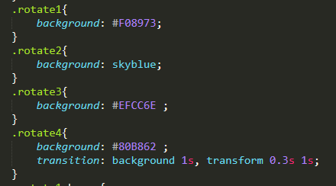

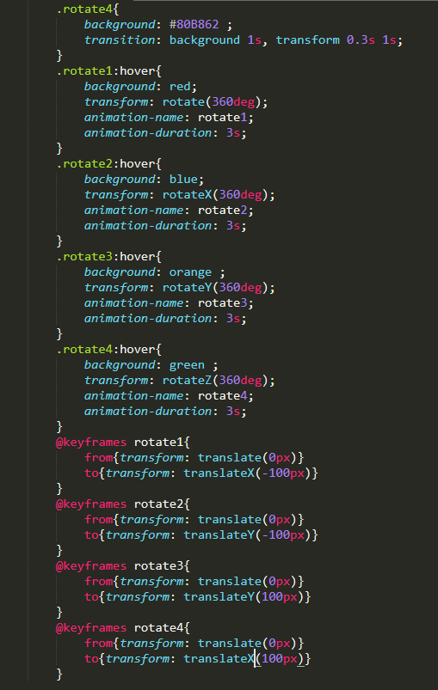

Fixed:

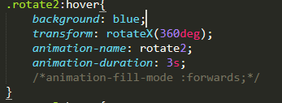

Delay:

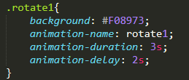

Fill & Delay:

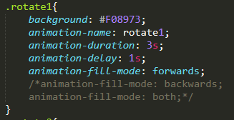

Repeat Animation: (iteration)

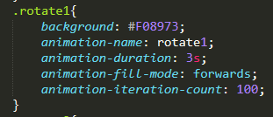 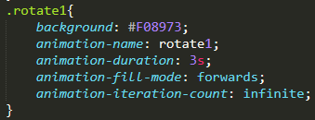

Diection:

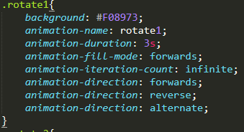

JAVASCRIPT:

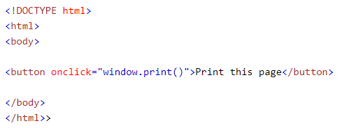

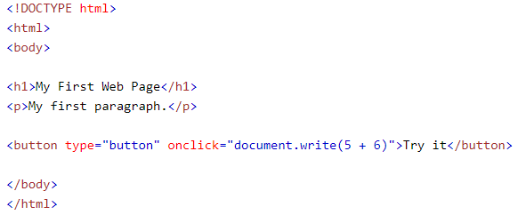

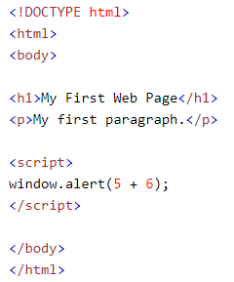

JQUERY:

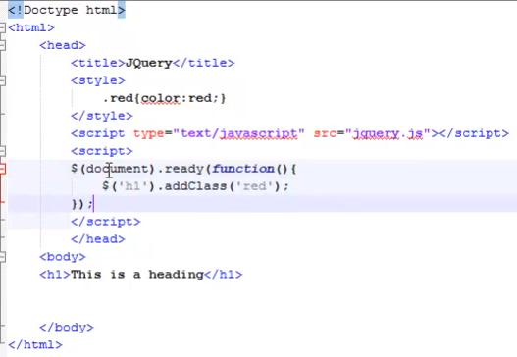

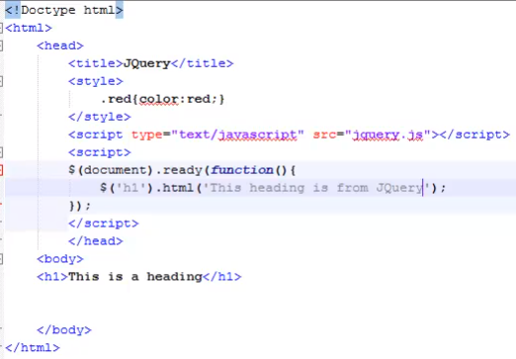

Up-Down Form:

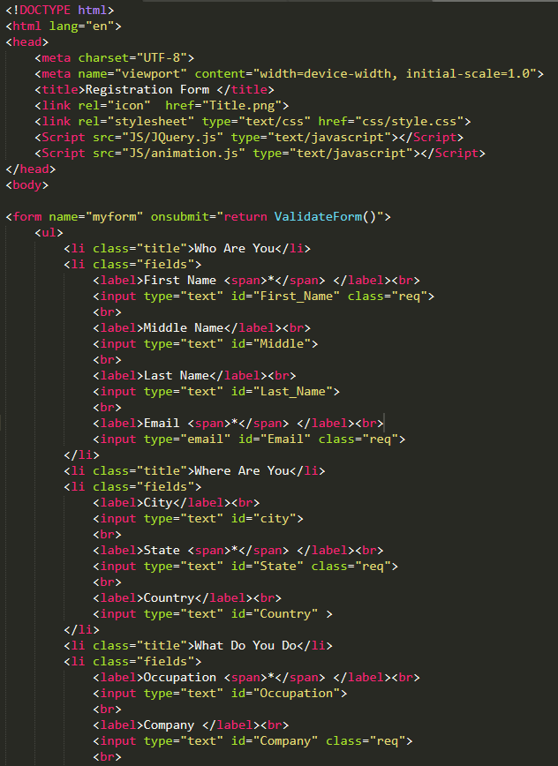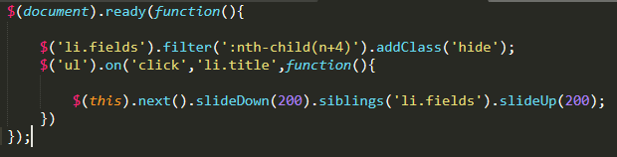

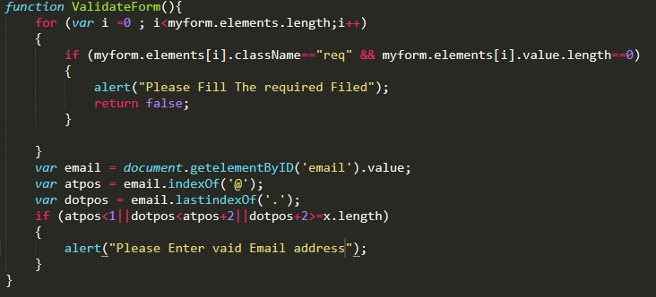

Slick Library:

